1.

The picture of the circuit.

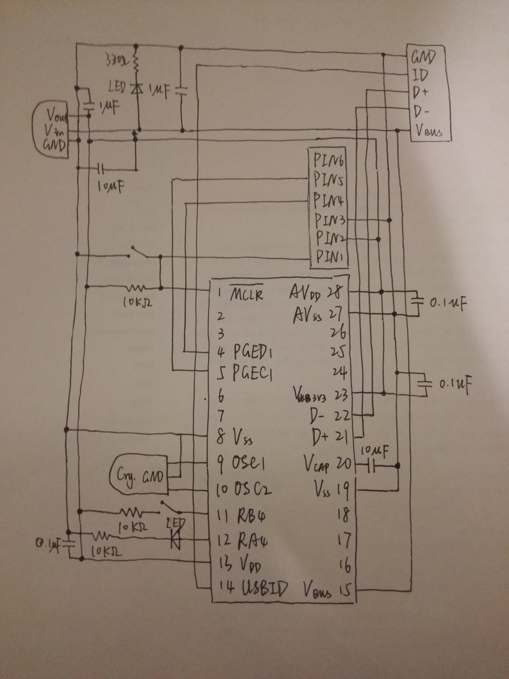

2.

The screenshot of some oscillations.

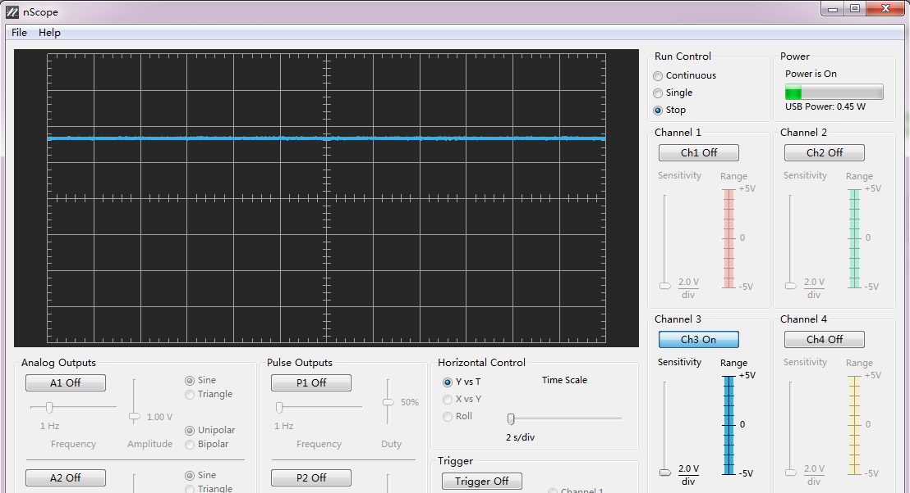

After adding the output 1uF capacitor, the oscillations go away.

The photo of the breadboard.

